Trendy Tunes

- MADE BY: -
- Noman Ali
- Rayan Asif
- Waleed Khan
- Danish Asif

Problem Statement

Music and Videos are the most common source of entertainment today.

SOUND Group wants to host a WEBSITE for Entertainment. Company is looking on hosting new and old Video’s and Songs in both REGIONAL and ENGLISH language.

WEBSITE should have proper menu structure and Music and Video should be arranged as per ALBUM, ARTIST, YEAR, GENRE, LANGUAGE etc.

Users should have option of reviewing and rating the Music and Video’s available.

Home Page should have information about the site and a section for latest music and video with 5-5 listing in each.

Customer Specifications:

Website will host information about songs and videos with images and description and “New” image/icon should flash along with the new additions to Music and Video’s.

The website will have three users/roles:
- Administrator
- USER

The Administrator should be able to do the following:

- Add Music files with information.
- Add Video files with information.
- Create Categories viz. YEAR, ARTIST, ALBUM etc.
- Delete Music files
- Delete Video files.
- Create/Manage Users/Logins
- Manage information/details on the WEBSITE

The USER should be able to do the following:

- Register/Create Account [USERID should be unique].
- Search for MUSIC/Video based on Name, ARTIST, YEAR, ALBUM etc.
- ADD/Modify Reviews
- ADD/Modify Ratings

Note: Name, Address, Phone Numbers, Email-ids should be mandatory to be provided. Proper Validations should be applied on all Data Fields.

Project should be submitted along with proper documentation and Database Backup.

Home Page
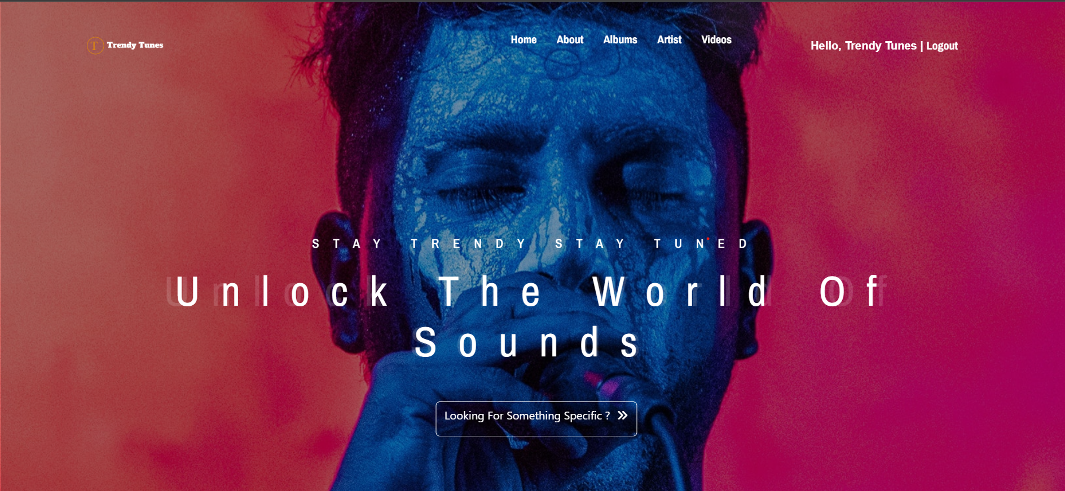

Categories With Album ,Artist ,Year ,Language
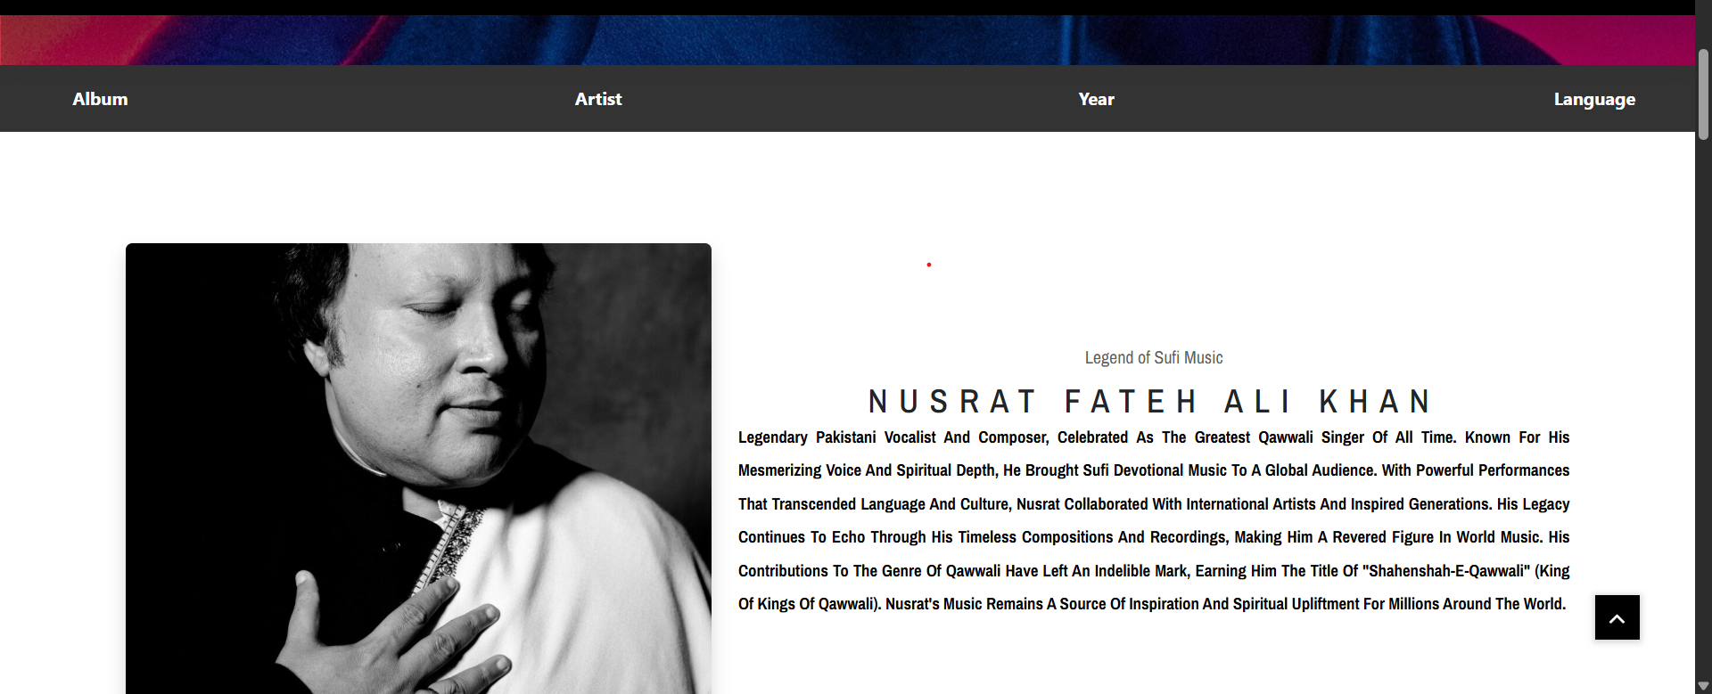

Section for Music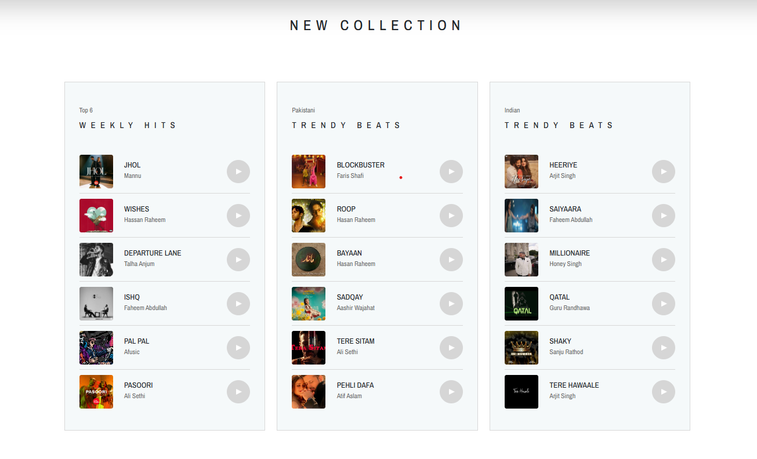

Section For Videos
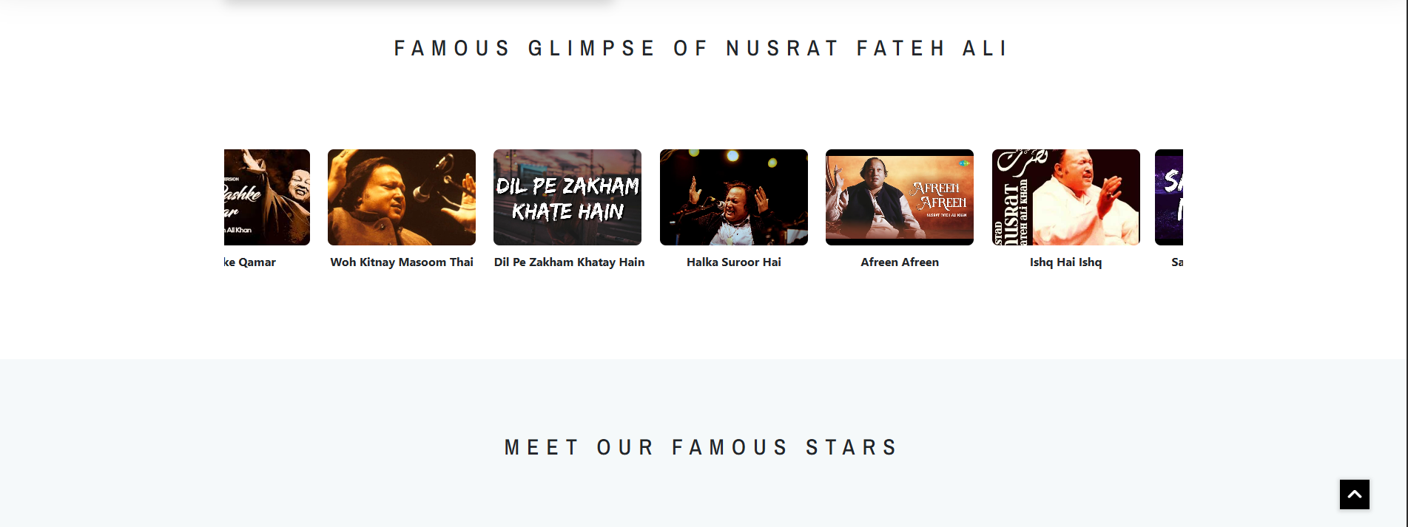

About Us Page
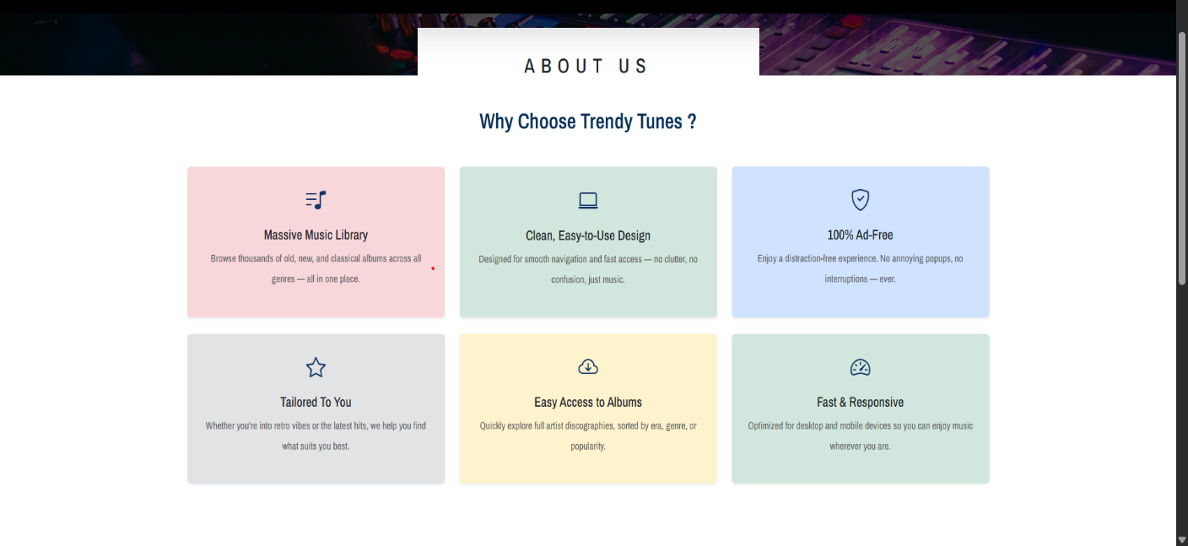

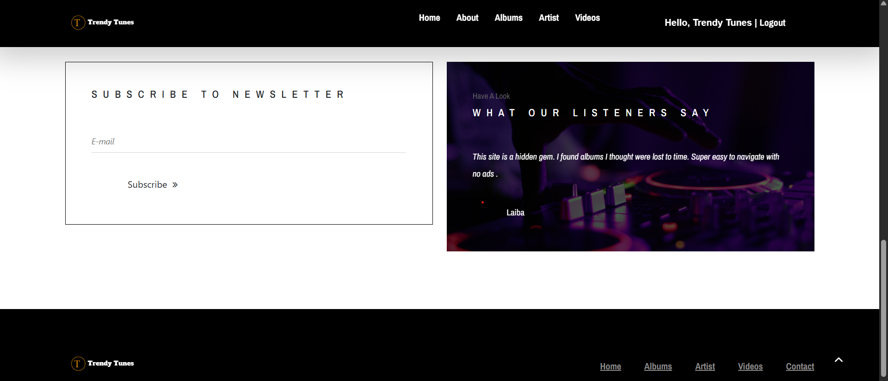

Admin Panel (Having users and one admin)
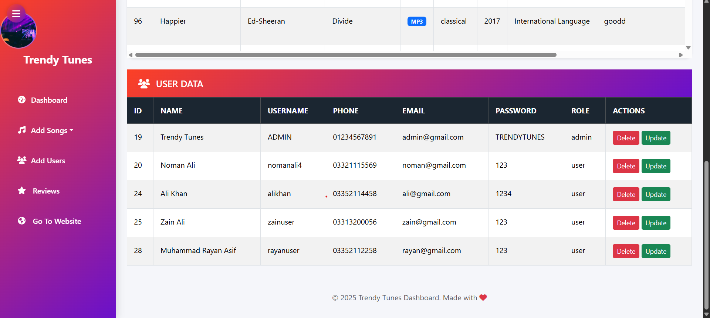
User Update
Before: -
After: -
User Delete
Before: -
After: -
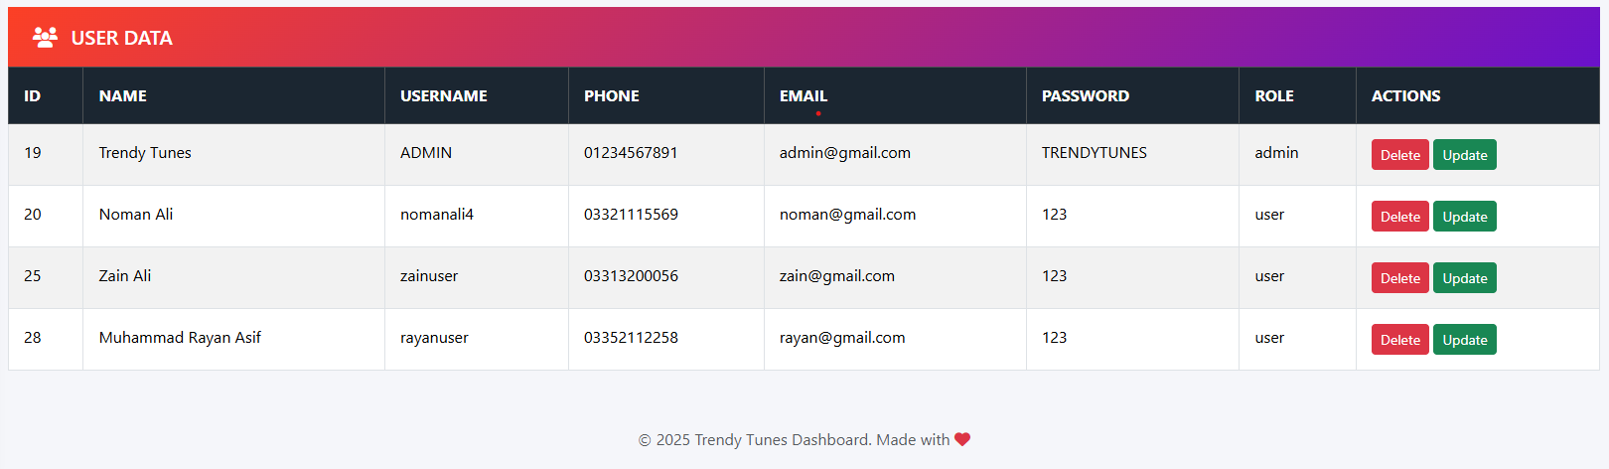
Add A Review
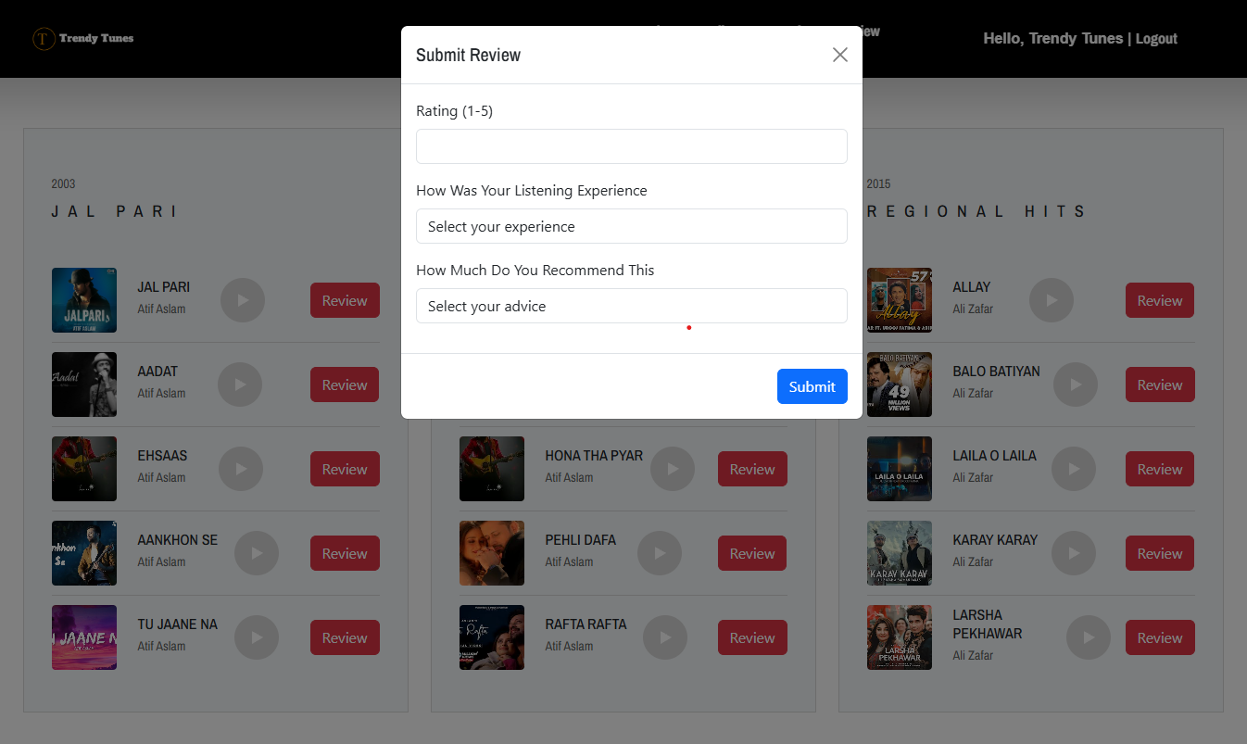

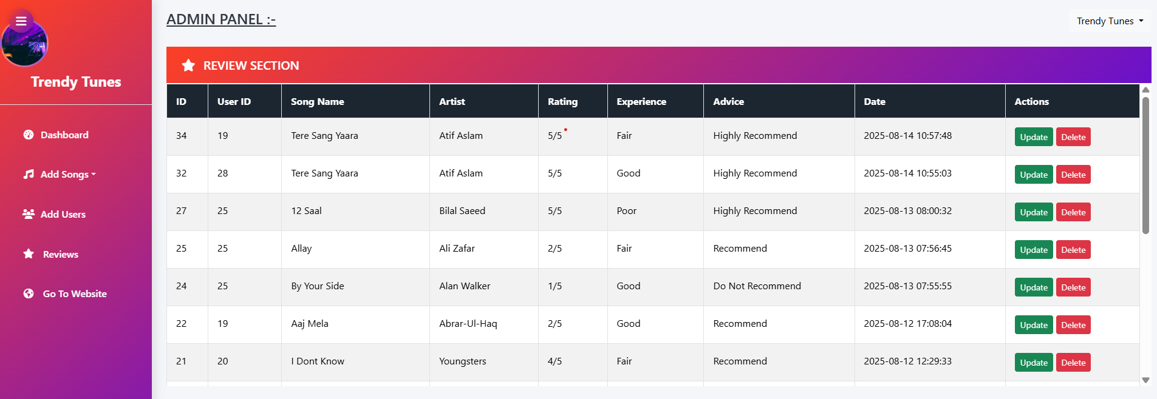

Categories
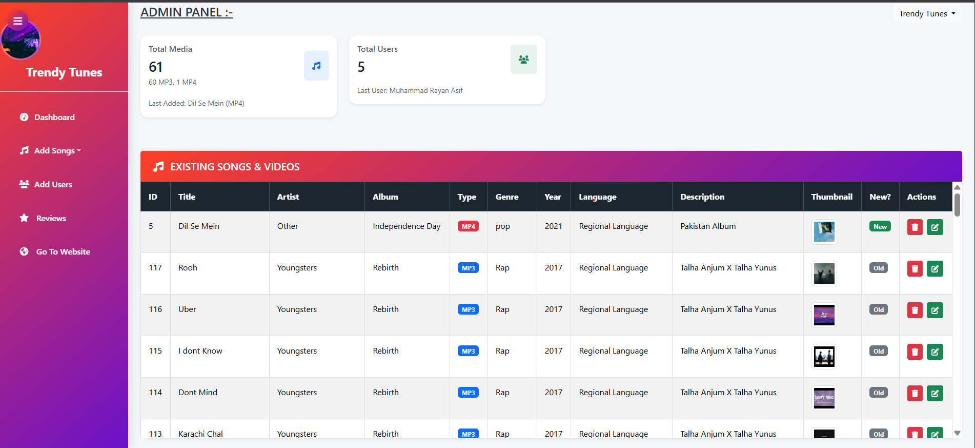

Add A Song
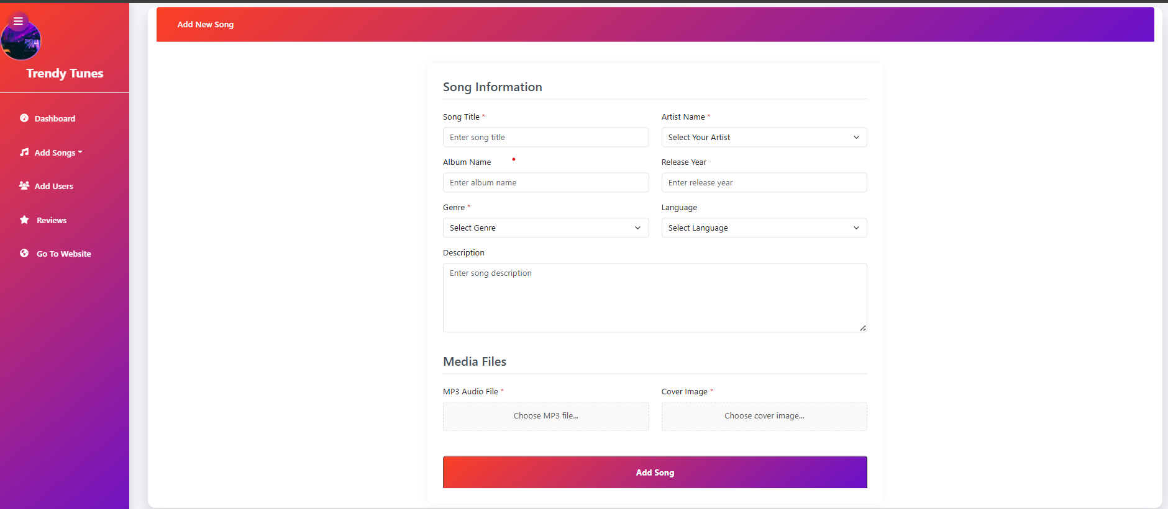

Add A Video
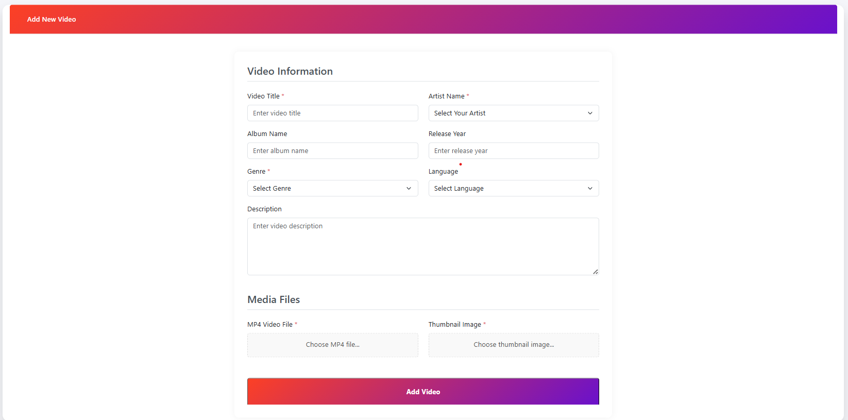

User Registration
